13 / 10 2017
Download and Install WAMP 3.1.0 (Windows, MySQL, Apache, PHP).
Start the WAMP server.
Go to PHP MY admin, create a new database eg kea.
Download and Install MySQL ODBC driver for windows 10 ver 32 bit.
Download and Install MySQL ODBC driver for windows 10 ver 64 bit.
In Controlpanel system administration ODBC datasources create a connection.
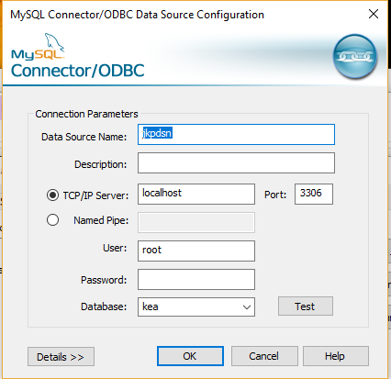
Now we are ready to test the connection from C#

Create a windows application
Append this line on the top
using System.Data.Odbc;

Make this global static connections and variables.

public partial class Form1 : Form
{
static public string sql;
static public string constr = "dsn=jkpdsn; name=root; pwd=";
static public OdbcConnection con;
static public OdbcCommand cmd;
static public OdbcDataReader rd;

somewhere in the program do this eg after InitializeComponent();
sql = "CREATE TABLE postal( ";
sql += " con_id int primary key auto_increment,";
sql += " pno int,";
sql += " city varchar(50));";
dbw();

private void dbw()
{
con = new OdbcConnection(constr);
cmd = new OdbcCommand(sql, con);
con.Open();
cmd.ExecuteNonQuery();
con.Close();
}

private void dbr()
{
con = new OdbcConnection(constr);
cmd = new OdbcCommand(sql, con);
con.Open();
rd = cmd.ExecuteReader();
}

run the program, be sure that the code above has been executed, turn the program off, and then on,
see if you get an error.

