2A_win_from_postalcode_to_cityname
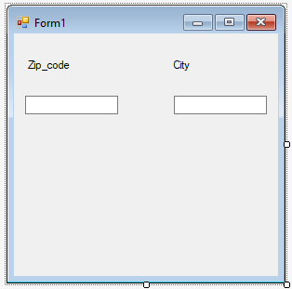
using System;
using System.Collections.Generic;
using System.ComponentModel;
using System.Data;
using System.Drawing;
using System.Linq;
using System.Text;
using System.Threading.Tasks;
using System.Windows.Forms;
using System.IO;

namespace _2a_win_winpostcity2209
{
public partial class Form1 : Form
{
public Form1()
{
InitializeComponent();
}

private void maskedTextBox1_MaskInputRejected(object sender, MaskInputRejectedEventArgs e)
{
}

private void maskedTextBox2_MaskInputRejected(object sender, MaskInputRejectedEventArgs e)
{

}

private void maskedTextBox1_TextChanged(object sender, EventArgs e)
{
if (maskedTextBox1.Text.Length == 4)
{
StreamReader sr = new StreamReader("winpostby.txt");
string str;
while ((str = sr.ReadLine()) != null)
{
string[] s = str.Split(';');
if (s[0] == maskedTextBox1.Text)
{
maskedTextBox2.Text = s[1];
}
}
sr.Close();

}
else
maskedTextBox2.Text = "";

}
}
}

