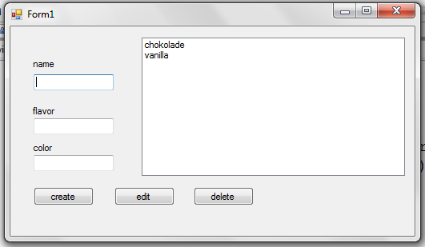
using System;
using System.Collections.Generic;
using System.ComponentModel;
using System.Data;
using System.Drawing;
using System.Text;
using System.Windows.Forms;
using System.Data.Odbc;

namespace fall2015windb02
{
public partial class Form1 : Form
{

static public OdbcConnection con = new OdbcConnection();
static public OdbcCommand cmd = new OdbcCommand();
static public OdbcDataReader rd ;
static public string constr = "dsn=jkpdsn; name=root; pwd=";
static public string sql;
static public int[] ind = new int[100];

public Form1()
{
InitializeComponent();
createtable();
updlb();
}

private void dbw()
{
con = new OdbcConnection(constr);
cmd = new OdbcCommand(sql, con);
con.Open();
cmd.ExecuteNonQuery();
con.Close();
}

private void dbr()
{
con = new OdbcConnection(constr);
cmd = new OdbcCommand(sql, con);
con.Open();
rd = cmd.ExecuteReader();
}

private void updlb()
{
int i = 0;
listBox1.Items.Clear();
sql = "select * from test2;";
dbr();
while (rd.Read())
{
listBox1.Items.Add(rd["name"].ToString());
ind[i++] = Convert.ToInt16(rd["i"]);
}
rd.Dispose();
con.Close();

}

private void createtable()
{
try
{
sql = " Create table test2 (";
sql += " i int primary key auto_increment,";
sql += " name varchar(20),";
sql += " flavor varchar(20),";
sql += " color varchar(20));";
//MessageBox.Show(sql);
dbw();
}
catch
{

}
}

private void Form1_Load(object sender, EventArgs e)
{

}

private void button1_Click(object sender, EventArgs e)
{
//create an ice
sql = "insert into test2 (name, flavor, color) values ('";
sql += textBox1.Text;
sql += "','";
sql += textBox2.Text;
sql += "','";
sql += textBox3.Text;
sql += "');";
MessageBox.Show(sql);
dbw();
textBox1.Text = "";
textBox2.Text = "";
textBox3.Text = "";
updlb();

}

private void listBox1_SelectedIndexChanged(object sender, EventArgs e)
{
sql = "select * from test2;";
dbr();
while (rd.Read())
{
if (Convert.ToInt16(rd["i"]) == ind[listBox1.SelectedIndex])
{
textBox1.Text = rd["name"].ToString();
textBox2.Text = rd["flavor"].ToString();
textBox3.Text = rd["color"].ToString();
}
}
rd.Dispose();
con.Close();
}

private void button3_Click(object sender, EventArgs e)
{
//delete an icecream
sql = "delete from test2 where i = ";
sql += ind[listBox1.SelectedIndex];
sql += ";";
MessageBox.Show(sql);
dbw();
updlb();
textBox1.Text = "";
textBox2.Text = "";
textBox3.Text = "";
}

private void button2_Click(object sender, EventArgs e)
{
//update
sql = "Update test2 set name = '";
sql += textBox1.Text;
sql += "', flavor = '";
sql += textBox2.Text;
sql += "',color = '";
sql += textBox3.Text;
sql += "' where i = ";
sql += ind[listBox1.SelectedIndex];
sql += ";";
dbw();
updlb();
textBox1.Text = "";
textBox2.Text = "";
textBox3.Text = "";

}
}
}

