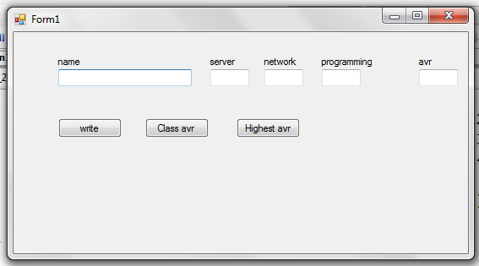
using System;
using System.Collections.Generic;
using System.ComponentModel;
using System.Data;
using System.Drawing;
using System.Text;
using System.Windows.Forms;

namespace fall_2015winarray
{
public partial class Form1 : Form
{

int[,] grade = new int[25, 4];
string[] name = new string[25];

public Form1()
{
int a, b;
InitializeComponent();
for (a = 1; a < 25; a++)
{
name[a] = "";
for (b = 1; b < 4; b++)
grade[a, b] = 0;
}

}

private void button1_Click(object sender, EventArgs e)
{
//write
int a;
for (a = 1; a < 25; a++)
{
if (name[a] == "")
{
break;
}
}
name[a] = textBox1.Text;
grade[a, 1] = Convert.ToInt16(textBox2.Text);
grade[a, 2] = Convert.ToInt16(textBox3.Text);
grade[a, 3] = Convert.ToInt16(textBox4.Text);

textBox1.Text = "";
textBox2.Text = "";
textBox3.Text = "";
textBox4.Text = "";
textBox5.Text = "";
MessageBox.Show(a.ToString());
}

private void textBox4_TextChanged(object sender, EventArgs e)
{
int a, b, c, d;
if ((textBox2.Text != "") && (textBox3.Text != "") && (textBox4.Text != ""))
{
a = Convert.ToInt16(textBox2.Text);
b = Convert.ToInt16(textBox3.Text);
c = Convert.ToInt16(textBox4.Text);
d = (a + b + c) / 3;
textBox5.Text = d.ToString();
}
}

private void button2_Click(object sender, EventArgs e)
{
//class avr
int Avr =0, Grade = 0 ;
int i,j;
for (i = 1; i < 25; i++)
{
if (name[i] == "")
break;
}
for (j = 1; j < i; j++)
{
Grade = Grade + grade[j, 1];
Grade = Grade + grade[j, 2];
Grade = Grade + grade[j, 3];
}
Avr = Grade / ((i - 1) * 3);
//MessageBox.Show("avr = "+Avr.ToString());
//MessageBox.Show("i-1 = "+(i-1));
//MessageBox.Show("i-1*3 = " + ((i - 1) * 3));
textBox5.Text = Avr.ToString();
}

private void button3_Click(object sender, EventArgs e)
{
//Highest avr
int a, b, c=0, d=0, i;
for (i = 1; i < 25; i++)
{
if (name[i] == "")
break;
a = grade[i, 1];
a += grade[i, 2];
a += grade[i, 3];
b = a / 3;
if (c < b)
{
c = b;
d = i;
}
}
textBox1.Text = name[d];

}
}
}

