This program is an example of an alarmclock.

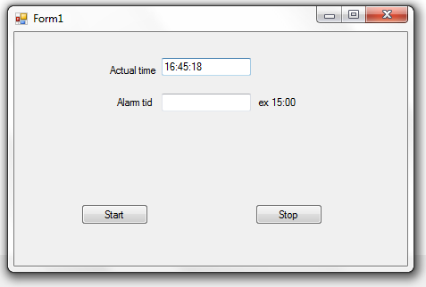
using System;
using System.Collections.Generic;
using System.ComponentModel;
using System.Data;
using System.Drawing;
using System.Text;
using System.Windows.Forms;
using System.Media;

namespace fall2015win04
{
public partial class Form1 : Form
{
static public DateTime actime, altime;
bool alarm = false;

public Form1()
{
InitializeComponent();
timer1.Enabled = true;
}

private void button1_Click(object sender, EventArgs e)
{
//start
alarm = true;
altime = new DateTime(2015,9,10,0,0,0);
string[] ti = textBox2.Text.Split(':');
altime = altime.AddHours(Convert.ToInt32(ti[0]));
altime = altime.AddMinutes(Convert.ToInt32(ti[1]));
}

private void timer1_Tick(object sender, EventArgs e)
{
actime = DateTime.Now;
textBox1.Text = actime.ToLongTimeString();

if (alarm == true)
{
if (altime.Hour == actime.Hour)
if (altime.Minute == actime.Minute)
{
//SystemSounds.Beep.Play();
SoundPlayer player = new SoundPlayer();

player.SoundLocation = "tada.wav";
player.Play();
}
}
}

private void button2_Click(object sender, EventArgs e)
{
//stop
alarm = false;
}
}
}

