Read a file and display the contents in a listBox – here select a file by OpenFileDialog

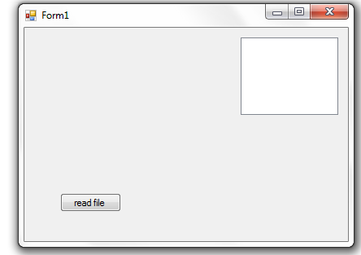
using System;
using System.Collections.Generic;
using System.ComponentModel;
using System.Data;
using System.Drawing;
using System.Text;
using System.Windows.Forms;
using System.IO;

namespace fall2015win03
{
public partial class Form1 : Form
{
public Form1()
{
InitializeComponent();
}

private void button1_Click(object sender, EventArgs e)
{

string file;
string line;
OpenFileDialog openFileDialog1 = new OpenFileDialog();
openFileDialog1.ShowDialog();
file = openFileDialog1.FileName;
StreamReader reader = new StreamReader(file);
while((line=reader.ReadLine())!=null)
listBox1.Items.Add(line);
reader.Close();
}
}
}

