When you press the button the program is generating a number of random numbers, they are entered in an array, they are written to a file, and sorted and displayed in a listbox.

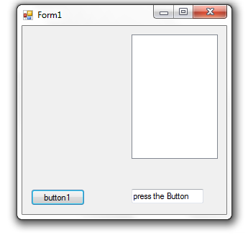
using System;
using System.Collections.Generic;
using System.ComponentModel;
using System.Data;
using System.Drawing;
using System.Text;
using System.Windows.Forms;
using System.IO;

namespace fall2015win02
{
public partial class Form1 : Form
{
static public int z = 10;
static public int[] anum = new int[z];

public Form1()
{
InitializeComponent();
textBox1.Text = "press the Button";
listBox1.Sorted = false;// true;
}

private void button1_Click(object sender, EventArgs e)
{
Random ran = new Random();
int num;
String[] lines = new string[z];
listBox1.Items.Clear();
for(int a=0;a<z;a++)
{
num=ran.Next(1,100);
anum[a] = num;
listBox1.Items.Add(num);
lines[a] = num.ToString();
}
File.WriteAllLines("text.txt", lines);
sort();
textBox1.Text="DONE";
}

private void sort()
{
int temp;
for (int write = 0; write < anum.Length; write++)
{
for (int sort = 0; sort < anum.Length - 1; sort++)
{
if (anum[sort] > anum[sort + 1])
{
temp = anum[sort + 1];
anum[sort + 1] = anum[sort];
anum[sort] = temp;
}
}
}
listBox1.Items.Clear();
for (int x = 0; x < z; x++)
listBox1.Items.Add(anum[x].ToString());
}
}
}

