This program does a change between the contents of the two textboxes every time the button is pressed.

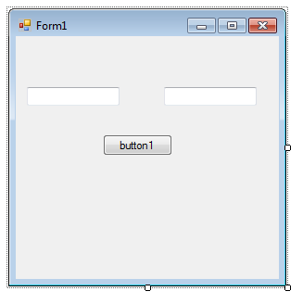
using System;
using System.Collections.Generic;
using System.ComponentModel;
using System.Data;
using System.Drawing;
using System.Text;
using System.Windows.Forms;

namespace fall2015win01
{
public partial class Form1 : Form
{
public Form1()
{
InitializeComponent();
textBox1.Text = "text1";
textBox2.Text = "text2";
}

private void button1_Click(object sender, EventArgs e)
{
string str;
str=textBox1.Text;
textBox1.Text=textBox2.Text;
textBox2.Text=str;
}
}
}

